241901005

Ex. No.: 3 PASSIVE AND ACTIVE RECONNAISSANCE

AIM:
To perform passive and active reconnaissance in TryHackMe platform.

ALGORITHM:

- Access the Passive reconnaissance lab in TryHackMe platform.
- Click Start AttackBox to run the instance of Kali Linux distribution.
- Run whois command on the website tryhackme.com and gather information about it.
- Find the IP address of tryhackme.com using nslookup and dig command.
- Find out the subdomain of tryhackme.com using DNSDumpster command.
- Run shodan.io to find out the details- IP address, Hosting Company, Geographical location and Server type and version.
- Access the Active reconnaissance lab in TryHackMe platform.
- Click Start AttackBox to run the instance of Kalilinux distribution.
- Perform active reconnaissance using the commands, traceroute, ping and netcat.

OUTPUT:

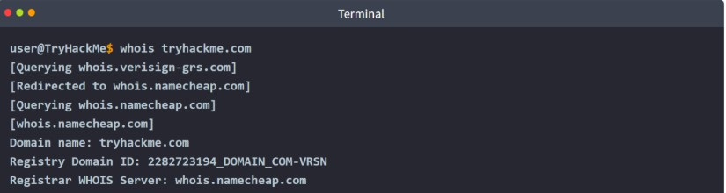

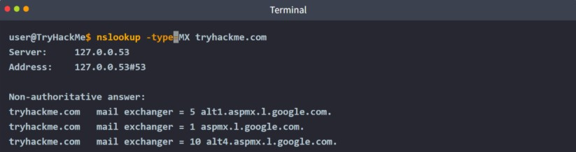

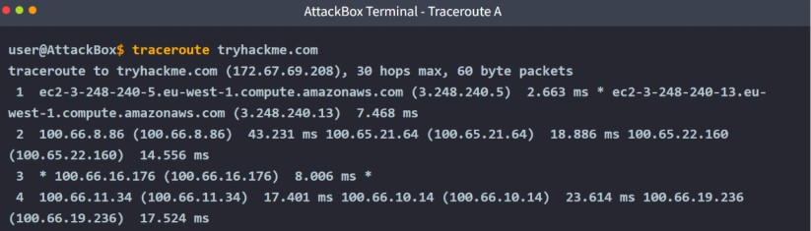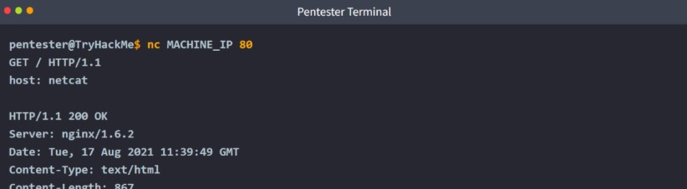

Result: Thus, the passive and active reconnaissance has been performed successfully in TryHackMe platform.

